**AEM – MSM, Dispatcher Set-up**

1. **What is MSM, Blueprint, Live Copy, and Rollout in AEM?**

**Multi-Site Manager (MSM):**

AEM’s Multi-Site Manager (MSM) allows organizations to efficiently manage multiple websites with a shared structure and content. It helps in creating, maintaining, and synchronizing content across different language and regional sites.

**Blueprint:**

A Blueprint is a master site that serves as the reference for creating multiple Live Copies. When changes are made in the Blueprint, they can be rolled out to all associated Live Copies.

**Live Copy:**

A Live Copy is a site or page that is created based on a Blueprint. It inherits content and structure from the Blueprint and can be updated using rollouts.

**Rollout:**

A rollout is the process of pushing changes from the Blueprint to its associated Live Copies. Rollouts can be manual or automated, ensuring that all sites remain up to date.

1. **What is a Language Copy?**

A Language Copy in AEM is a site structure that is created for translating content into different languages. Unlike MSM Live Copies, Language Copies are independent after creation, meaning they do not inherit updates from the

original source. These are used for localization.

1. **Create a Site Using MSM with us/en as the Source**

Steps to Create a Site Using MSM:

* 1. Create the Source Blueprint (us/en):
     + Navigate to AEM Sites → Create a new site using the We.Retail or WKND template.
     + Set the us/en page as the Blueprint source.
  2. Create a Live Copy:
     + Select the us/en page → Click Create Live Copy.
     + Set the destination path, e.g., /content/mysite/uk/en/.
     + Choose Inherit from Blueprint.
  3. Define the Rollout Configurations:
     + Go to Tools → MSM Control Center.
     + Configure rollout settings to define which properties, components, and content should be synchronized.
  4. Modify the Live Copy and Test Rollouts:
     + Edit the Blueprint (us/en) and roll out changes.
     + Check if the updates reflect on the Live Copy (e.g., UK site).

**Screenshot**

Live copy of en , fr was created

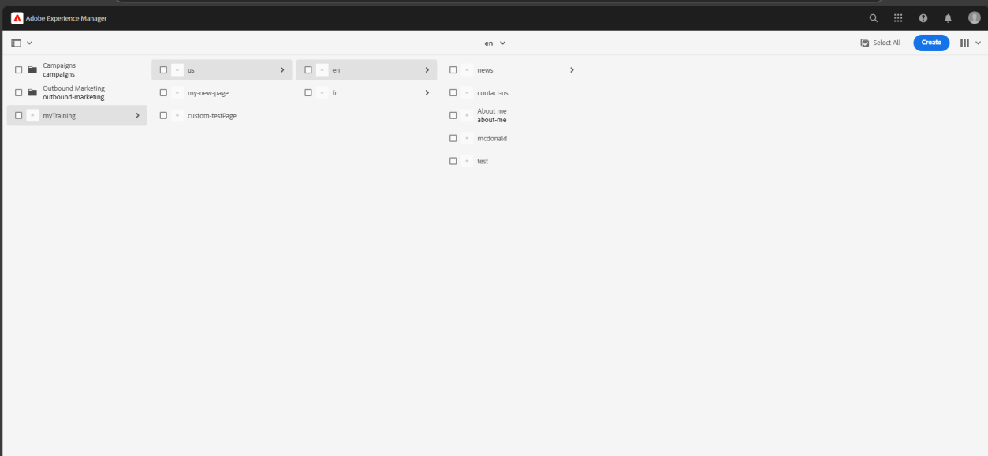

Language copy

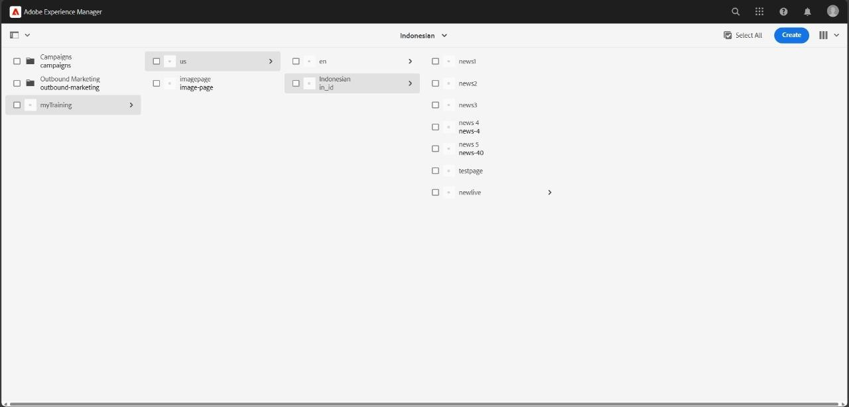

1. **. Create a McDonald’s Page in AEM and Author It Using Components**

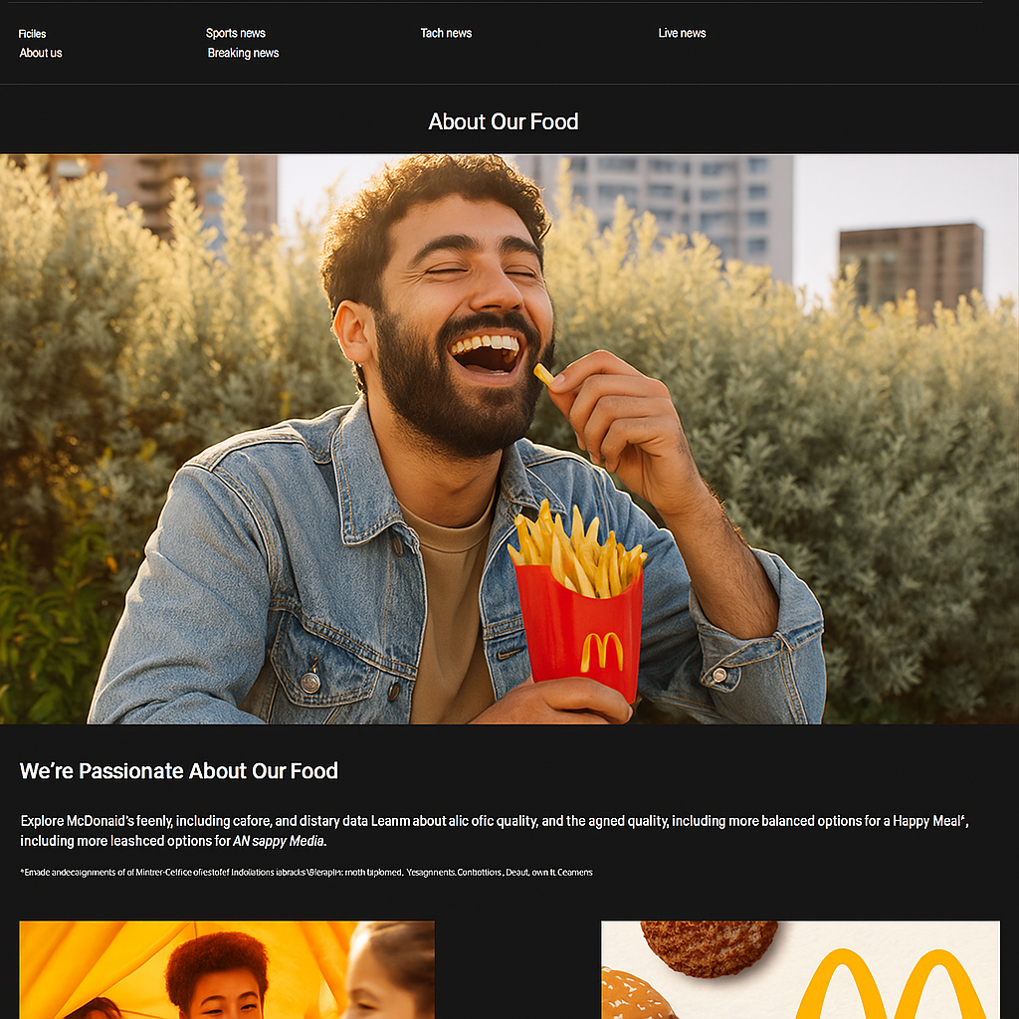

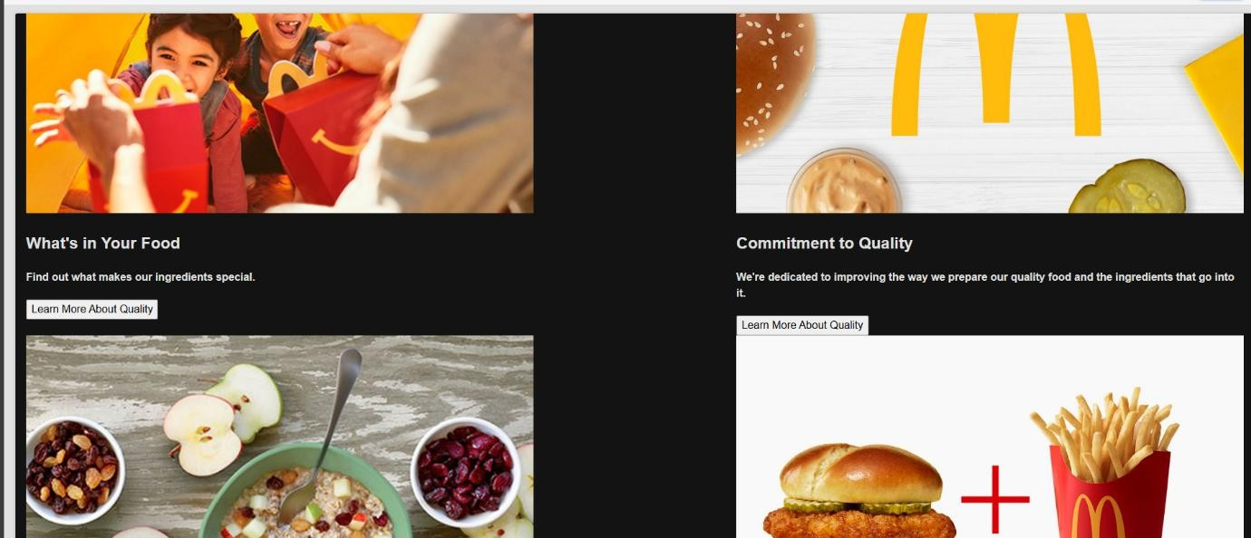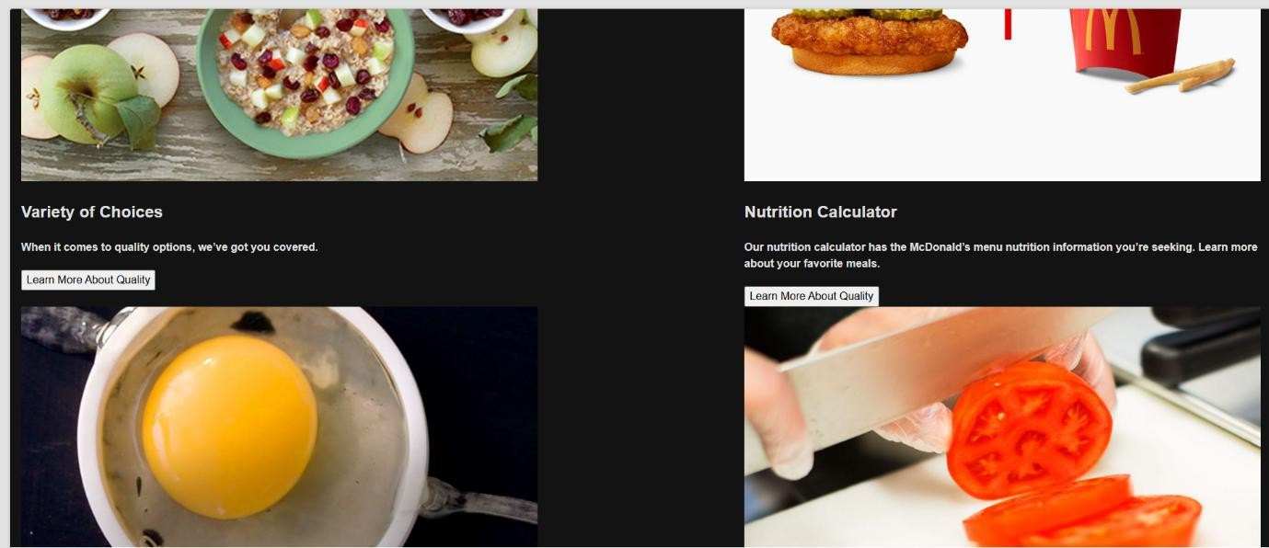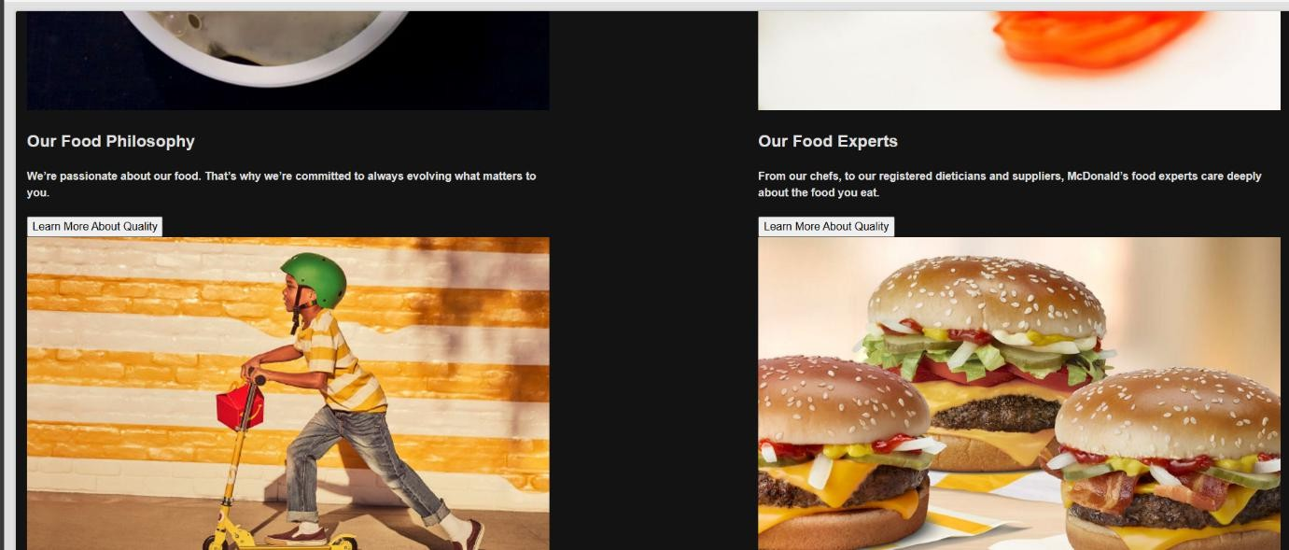

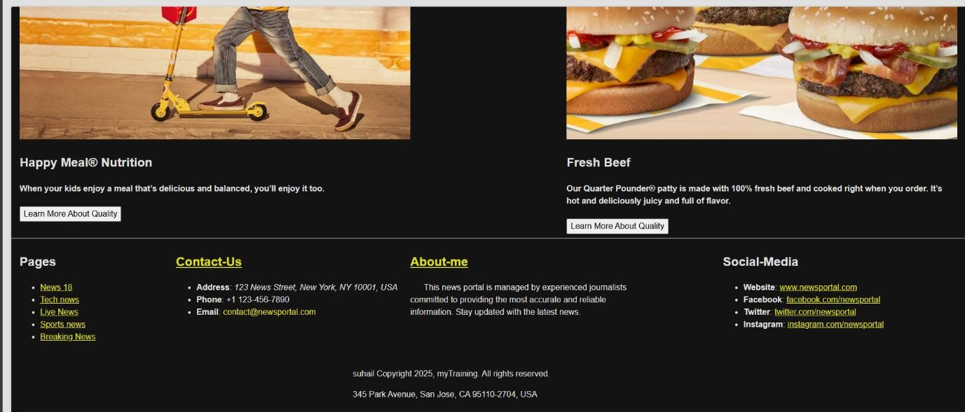

1. **Dispatcher setup**

